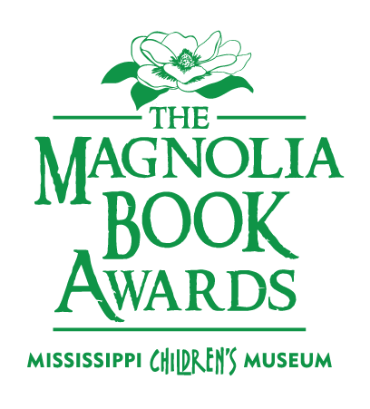

PRE-K - 2ND GRADE
A Boy, a Mouse, and a Spider: The Story of E. B. White
by Barbara Herkert

Eugenia Lincoln and the Unexpected Package: Tales from Deckawoo Drive, Volume Four
by Kate DiCamillo

Mrs. McBee Leaves Rm. 3
by Gretchen Brandenburg McLellan

Prince Ribbit
by Jonathan Emmett

Her Right Foot
By Dave Eggers

Hattie and Hudson
by Chris Van Dusen

The Day I Ran Away
by Holly L. Niner

The Treasure Box
by Margaret Wild

Give Me Back My Book!
by Travis Foster

No More Noisy Nights
by Holly L. Niner

2019 Short List

Read each book in your grade category, and
VOTE
in February 2019!

3RD - 5TH GRADE
Big and Little Questions (according to Wren Jo Byrd)
by Julie Bowe

How to Be An Elephant : growing up in the African wild
by Katherine Roy

Lighter Than Air : Sophie Blanchard, the first woman pilot
by Matthew Clark Smith

Lou Lou and Pea and the Mural Mystery
by Lesley Vamos

Matylda Bright and Tender
by Holly M. McGhee

Not so different : what you really want to ask about having a disability
by Shane Burcaw

Seven and a half Tons of Steel
By Janet Nolan

The Real McCoys (Book 1) by Swanson/Behr

Short
by Holly Goldberg Sloan

Schomburg: The Man Who Built A Library
by Carole Boston Weatherford
6TH - 8TH GRADE
42 is not just a number : the odyssey of Jackie Robinson, American hero
by Doreen Rappaport

The Wonderling
by Mira Bartok

Alex & Eliza: A Love Story
by Melissa de la Cruz

Giant Pumpkin Suite
by Melanie Heuiser Hill

Isaac, The Alchemist: Secrets of Isaac Newton, Reveal'd
by Mary Losure

The Unexpected Life of Oliver Cromwell Pitts: being an absolutely accurate autobiographical account of my follies, fortunes, & fate written by himself
by Avi

Laura Ingalls is Ruining My Life
by Shelley Tougas

9TH -12TH GRADE
Here We Are: 44 Voices Write, Draw and Speak about Feminism for the Real World
by Jenson Kelly (Editor)

Moxie by Jennifer Matthieu

Bang by Barry Lyga

Strange the Dreamer
by Laini Taylor

You Bring the Distant Near
by Mitali Perkins

The Gentleman's Guide to Vice and Virtue
by Mackenzie Lee

