Instructions for Completing a Bi-Weekly Time Sheet

The University has updated the bi-weekly time sheet in order to capture additional information not currently being tracked. The new time sheet is as follows:

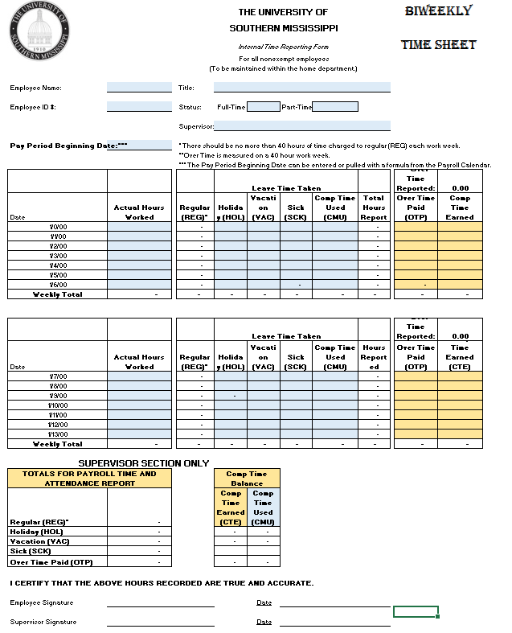

Instructions for completion:

- The only fields on the time sheet that require data entry are the colored fields. Complete the colored fields in Header section of the time sheet, which includes Name, Title, ID #, Status and Supervisor.

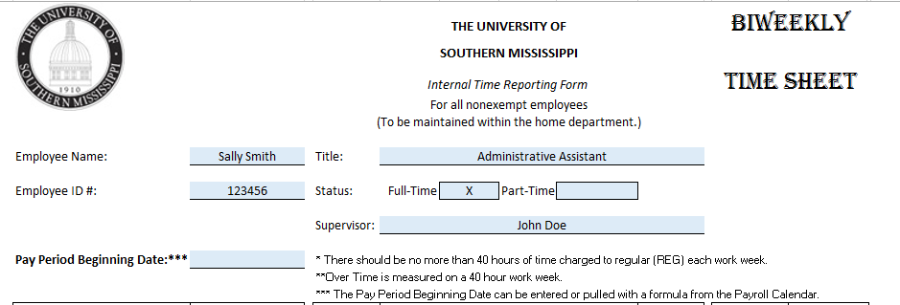
HEADER

- Complete the Week 1 section of the time sheet during week one of the bi-weekly pay period
  - Enter Pay Period Beginning Date (pay period begin dates are always a Saturday because the USM work week officially begins on Saturday at 12:00 AM and ends on Friday at 11:59 PM).
  - The Date column will auto-populate based on Pay Period Beginning date keyed above.
  - Enter Actual Hours Worked (it is recommended that time be recorded on a daily basis in an effort to reduce errors). Only enter hours actually worked in this column, not Holiday or Benefit Time.
  - Regular (REG) Hours column defaults from Actual Hours Worked Column.
  - Enter any Leave Time Taken in the appropriate column (Holiday, Vacation, Sick or Comp Time Used).
  - Total Hours Reported is a sum of the previous columns.
  - Enter any actual hours worked over 40 in either the Over Time Paid or Comp Time Earned columns based on the supervisor’s instructions.
  - Weekly Total is a sum of above columns.
- Complete the Week 2 section of the time sheet in the same manner as Week 1.
a.
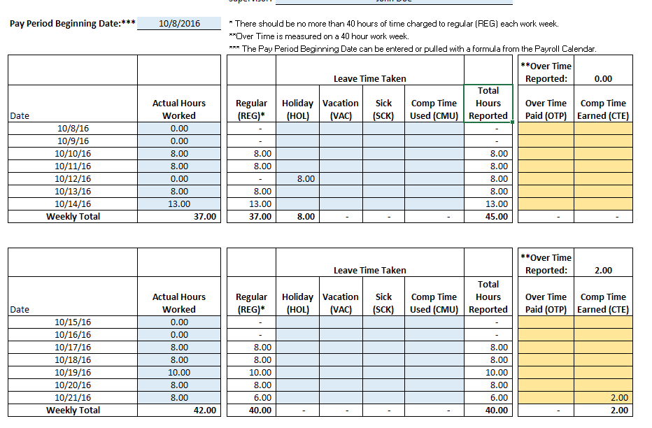
f.
g.
e.
d.
c.
b.
h.
Week 2
Week 1
- Once the pay period is complete, sign and date the time sheet and turn it in to your immediate supervisor for approval.
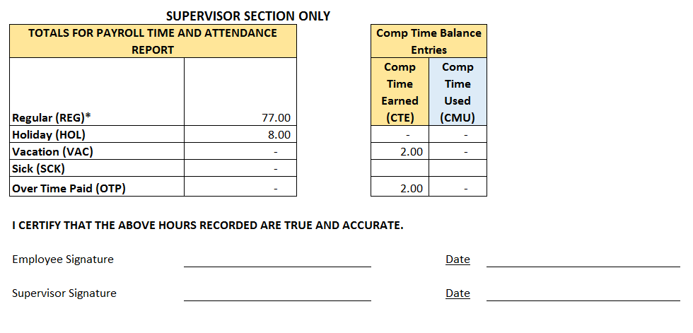
10/22/2016
John Doe
10/21/2016
Sally Smith
Signatures

