Instructions for Tracking Comp Time Earned & Comp Time Used

- Compensatory time is credited at 1 ½ hours per every hour worked over 40.
- Holidays, personal time, sick time, etc. are not considered as “hours worked” by the Department of Labor.
- The choice between compensatory time, flex-time, or monetary payment for overtime hours is at the discretion of the manager.
- An employee may only earn up to 240 hours (160 hours of actual overtime worked) of compensatory time.
- At the time 240 hours of comp time is accrued the manager can choose to deny overtime; however if overtime is taken without approval it must be paid at 1 ½ times the regular hourly pay rate.
- The employer can require an employee to use comp time before using personal time.
- If an employee transfers to a different department all current comp time must either be taken or paid out by the current department before the transfer occurs.
- Any unused compensatory time must be paid out at the time of termination from the university.
- The FLSA does not require that an employer credit compensatory time for any holidays, unless an employee works over 40 hours in that work week.
- The department can refuse a request for comp time if the time that is requested off places an “undue hardship” on the department.
- It is the responsibility of the employee and their supervisor to accurately track comp time that is accrued and taken. We are providing an excel spreadsheet template to assist with tracking this time. Please complete the template as follows:

- In the Comp Time Tracking workbook, copy and paste a spreadsheet for each non-exempt hourly employee. Rename the tab using the employee’s name, e.g. Sally Smith, add the employee’s name to the top right employee field, and change the department field.
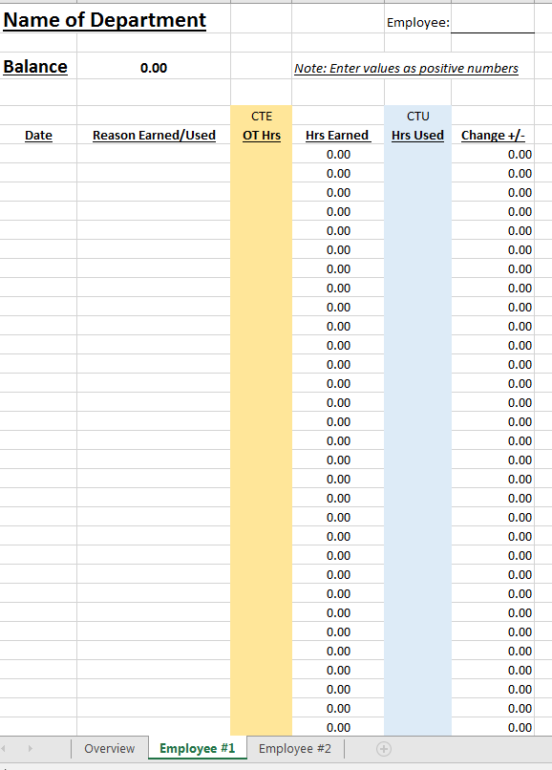
Copy and paste a tab for each employee and rename the tab using the employee’s name, e.g. Sally Smith.
2. Locate the employee’s Comp Time Balance entries for the associated pay period at the bottom of the employee’s time sheet.

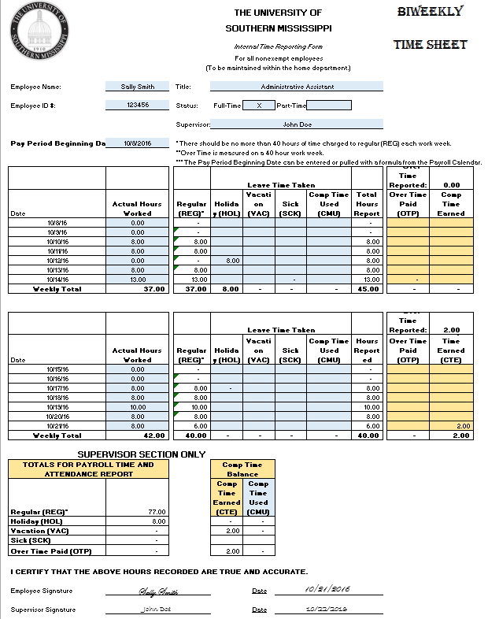
The Employee’s Comp Time Balance Entries

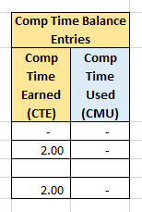

- Enter the date and reason associated with the comp time earned or the comp time used. Then transfer the hours in the comp time balance entries section of the employee’s time sheet to Comp Time Tracking workbook on the designated tab or spreadsheet for the employee, e.g. Sally Smith.

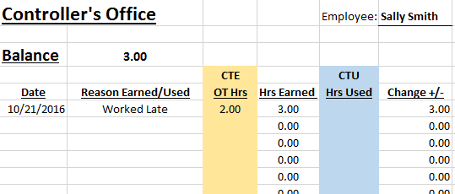
Transfer Employee’s Comp Time Balance Entries to Comp Time Tracking workbook

- The data entered on each employee tab, e.g. Sally Smith, should be linked back to the supervisor’s and or manager’s Overview tab along with the corresponding available comp time balance.

