|  |
| --- |
| **The University of Southern Mississippi**  **Office of Fiscal Planning and Analysis** |

**GLCOMBO TRAINING DOCUMENT**

Trainer: Melissa Bastine & Agustina Pesci

Email: [Melissa.Bastine@usm.edu](mailto:Melissa.Bastine@usm.edu) – Agustina.pesci@usm.edu

Desk: 601-266-6677 – 601-266-6755

Main Office: 601.266.4632

This training session will cover the following topics:

1. **Chart of Accounts/Fund Codes page 2**
2. **Eaglevision page 6**
3. **Budgets Overview page 10**
4. **Drill Down/ Departmental Deposit page 14**
5. **Monthly Detail Report (MDR) page 25**
6. **Payroll Distribution Report (PDR) page 37**
7. **Chart of Accounts**

PeopleSoft is the ERP (Enterprise Resource Planning) system used by Southern Miss. The financials management module of PeopleSoft is internally referred to as SOARFIN. Chartfield is a SOARFIN term used to define the data elements that will constitute the University’s Chart of Accounts. Southern Miss uses eight chartfields in SOARFIN that comprise the Chart of Accounts (COA).

**Business Unit:** The business unit is the legal business entity for which financial statements are reported at the end of a fiscal year

**Account:** The account is defined as the natural classification of financial transactions used for recording and summarizing assets, liabilities, fund balance, revenues or expenses. (e.g., travel, office supplies, salary, etc.). Accounts starting with 4% are revenue and those starting with 6% are expenses.

**Fund:** The fund is defined as a self-balancing group of chartfield strings, established for unique budgeting, funding, accounting (including external financial reporting), and operational requirements. Those beginning with 10% are E&G, 12% or 13% are Auxiliary, 14% are Designated and 16% are Restricted Funds. The middle letter indicates the location: H for Hattiesburg, G for Gulf Park, L for GCRL, S for Stennis, P for MS Polymer Institute.

**Department**: An academic or administrative unit that has a common programmatic, operational, and fiscal (including budgetary) responsibility.

**Program:** Group of common ongoing activities for which financial activity needs to be tracked and budgeted. These activities may occur within a single department or across multiple departments. Unique activities for which financial information needs to be tracked will also be accommodated here.

**Project/Grant**: Optional field which is 7 characters in length and used for activities that are temporary in duration and for which revenues and expenditures may be accumulated over more than one fiscal year.

* Not all chartfields are required for every transaction.
* Minimum requirements for every transaction are Business Unit, Account, Fund, DeptID, and Program.
* Each chartfield provides key information related to the transaction.
* It is important that each chartfield capture a single concept related to the transaction.
* The combination of chartfields make-up a “budget string” and will determine how transactions are posted to the University’s General Ledger.

**Budget String Example**

|  |  |  |  |  |  |  |  |
| --- | --- | --- | --- | --- | --- | --- | --- |
| **Business Unit** | **Account** | **Fund** | **Department** | **Program** | **Project** | **PC Business Unit** | **Activity** |
| USM01 | 606120 | 14H40 | 110002 | 06000 | DE00001 | USMPC | 00000 |

|  |  |
| --- | --- |
|  | All budget strings contain these Chartfields. |
|  | Always required for sponsored projects (Fund 16%), designated fund special projects (Fund 14%30, 14%40) and capital projects (Fund 40%). |

For additional details please visit:

<http://www.usm.edu/controller/chart-accounts>

**Fund Types**

|  |  |  |
| --- | --- | --- |
| **Fund Code** | **Type of Funds** | **Primary Funding Source** |
| 10XXX | Education & General (E&G) | Tuition & Fees, State appropriations |
| 12XXX | Auxiliary | Student Activity fees / Self- generated revenue |
| 13XXX | Athletics | Student Activity Fees /Self- generated revenue |
| 14X10 | Designated | Course and Lab Fees |
| 14X20  14X25 | Designated | Carryover funds, facilities and administrative (F&A) cost recovery, support from USM Foundation |
| 14X30 | Designated (DE) | Lucas Endowment Funds |
| 14X40 | Designated (DE) | Special projects- consists of seed/ start-up funds that are linked to an individual and applicable home department, salary recoveries and other funds earmarked or under the direction of a specific person or specific project / activity |
| 14X50 | Designated (Study Abroad) | Study Abroad program funds and English Language Institute |
| 16XXX | Restricted (Grants) | External funds from Sponsored Programs- Federal & State agencies, nongovernmental entities |
| 40XXX | Unexpended Plant | State Bond funds, private gifts, SMEBC bond proceeds, Capital Expense Appropriations |

**Budget Categories/Controls**:

1- For E&G and Auxiliary Funds:

SALARY and FRINGE are put into one bucket. (Non-Discretionary)

WAGE, TRAVEL, COMMOD, CONTSV, etc. are put into another bucket – call it “Other”. (Discretionary)

As long as the “Other” bucket has a positive remaining spending authority overall, you can spend across budget categories with no budget error issues. If funding in the “Other” bucket is exhausted, you cannot spend into the SALARY/FRINGE bucket, as these funds are considered non-discretionary.

|  |  |  |
| --- | --- | --- |
| **General Ledger** | | |
| **APPR** | **ORG** | **Major Category Represented** |
| PERSVC | SALARY | Salaries |
|  | FRINGE | Fringe Benefits |
|  | WAGES | Wages |
|  | COMMOD | Commodities |
|  | CONTSV | Contract Services |
| OTHER | TRAVEL | Travel and Subsistence |
|  | EQUIP | Equipment |
|  | CAPOUT | Capital Outlay |
|  | MANXFR | Mandatory Transfers |
|  | NMXFRS | NonMandatory Transfers |
|  | PURCH | Purchases (Auxiliaries Only) |

2- For Designated Funds:

The balance of your budget is – how much you can spend without getting a budget error notification.

**Note: Program Codes** are setup as 000000 for budget purposes but expenses will need actual program code (i.e., 01001, 02001, 03000, etc.)

3- For Restricted Funds (Grants):

You must have available monies in each budget category. That is the standard rule for budgets on grants; however, each grant is special – so check to make sure what the budget rules are for your particular grant(s). Also some of the restricted funds have additional categories not listed above.

**2 - Eaglevision**

Eaglevision is a tool in SOARFIN used to review budget string information including budget name, fund code, department ID, program code, project ID, signature authorities, and box number.

The following procedures are used to look up your budget string information in Eaglevision.

**Keep in mind:**

A) Use current fiscal year (if you want to see the information just for that specific year but you can also retrieve information for a previous fiscal year)

B) Select “contains” from drop down when searching by empl ID or name

C) You can copy/paste the results data into Excel. (Once you paste the data in Excel, right-click and click Remove Hyperlinks to remove the links and format it to text.)

D) Only active/open periods will pull with this search (for Budgets that include a Project/ Grant)

**Navigation**: Main Menu 🡪 USM Procedures 🡪 USM Eaglevision View-Only

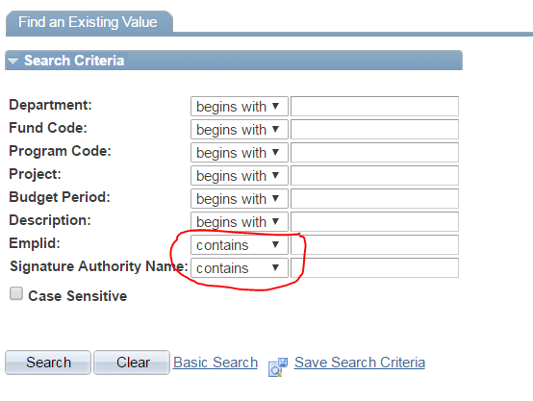

**Enter data into one or more search criteria fields.**

**Department:** Enter the department id.

**Fund Code:** Enter the fund.

**Program Code**:** Enter the program code (for funds other than designated funds)

**Project/Grant:** Enter Grant or Project number (i.e. GR##### or DE#####).

**Emplid:\*** Enter the employee ID number (Emplid) of the signature authority (do NOT include the preceding W).

**Signature Authority Name: \*** Enter the name of the signature authority.

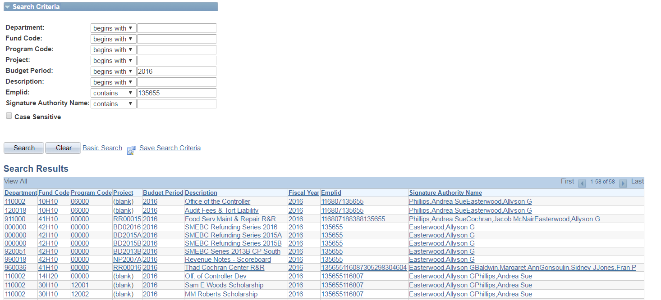

*When searching by either the Emplid or Signature Authority Name fields you **need to** change the drop down box to “contains” instead of begins with. If you do not do this step, you will not receive the full results for the signature authority entered.

**When searching for designated funds, leave the program code field blank or enter all zeros.

**<Click on>** the  button.

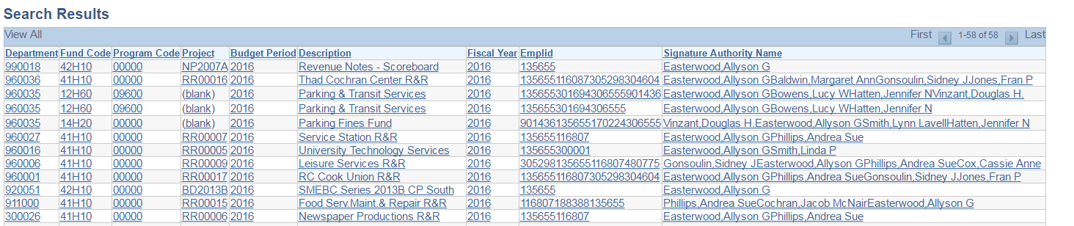

Search results will be displayed below the criteria. Locate the desired budget and **<click on>** any of the fields for that budget.

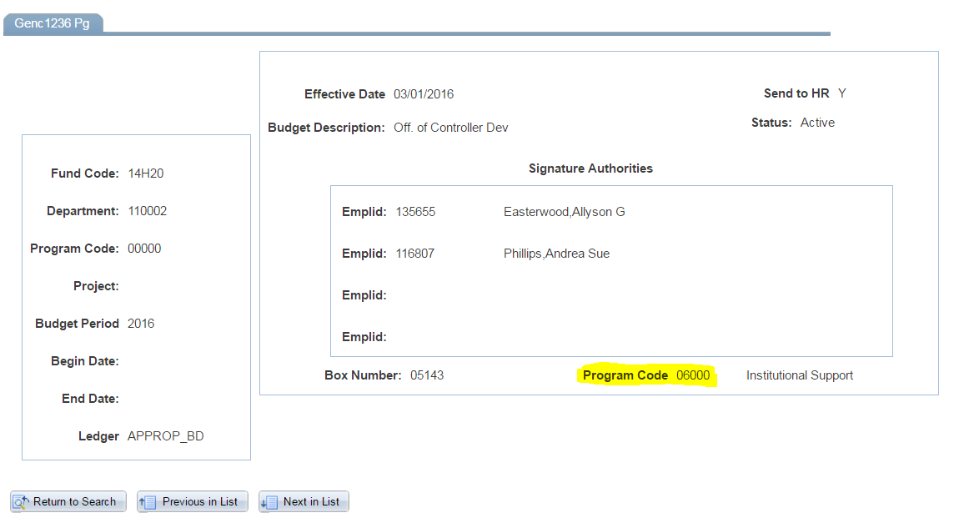

(Program Code location for designated budgets)

The detail for the budget will be displayed as shown above. The left side of the panel will display the budget string as set up on the budget ledger (commitment control in SOARFIN). The right side of the panel will display the most current signature authorities, budget name, box number, and program code assigned to designated funds (should be used for revenue/expense transactions).

**3 - Budgets Overview**

This is a feature of SOARFIN that will allow you to look at individual budgets online for a real-time balance. (This is like looking at your checking account online to see what the bank has posted.)

**Navigation:** Commitment Control – Review Budget Activities – Budgets Overview

(If first time, “Add a New Value” and create an Inquiry Name)

(Any other time, click SEARCH)

Helpful Hint: Set up each budget with a different Inquiry Name. This will allow you to set each budget up one time. The only information that you will have to change is the From Budget Period to Budget Period.

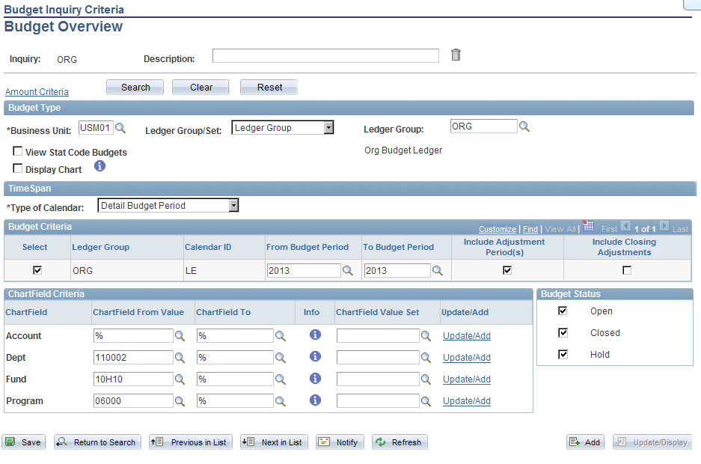

Business Unit = USM01

Ledger Group =

To look at the overall budget and **expense details**:

Fund Code like 10XXX, 12XXX or 13XXX = ORG

Fund Code like 14X10, 14X20, 14X50 or 50XXX = APPROP

Fund Code like 14X30, 14X40 or 16XXX = PROJ_GRT

To look at the **revenue details**:

Fund Code like 14X10, 14X20, 14x50, or 50XXX = REVEST

Fund Code like 14X30, 14X40 = PROJ_REV

Budget Period –will default into panel based on selection of Ledger Group. No change is necessary unless you want to view prior fiscal year. We do not recommend viewing multiple budget periods at one time.

Chartfield From Value – remove the percent signs (wild card) in the appropriate lines and enter your budget string information. To look at overall budget activity; do NOT remove the percent signs from ACCOUNT.

To pull budget information, it is not necessary to enter all chartfields contained in your budget string. Minimum chartfields required are as follows:

ORG & REVEST like 10, 12 and 13 = Fund, Dept ID and Program

APPROP & REVEST like 14X10, 14X20 = Fund & Dept ID

APPROP & REVEST like 50XXX = Program

APPROP & REVEST like 14X50 = Fund, Dept ID and Program

PROJ_GRT & PROJ_REV like 14X30 & 14X40 = Project

PROJ_GRT like 16XXX = Project

Click SAVE

Click SEARCH

Note: To view one particular budget category (SALARY, TRAVEL, ETC.), remove the percent signs and enter the name of the budget category.

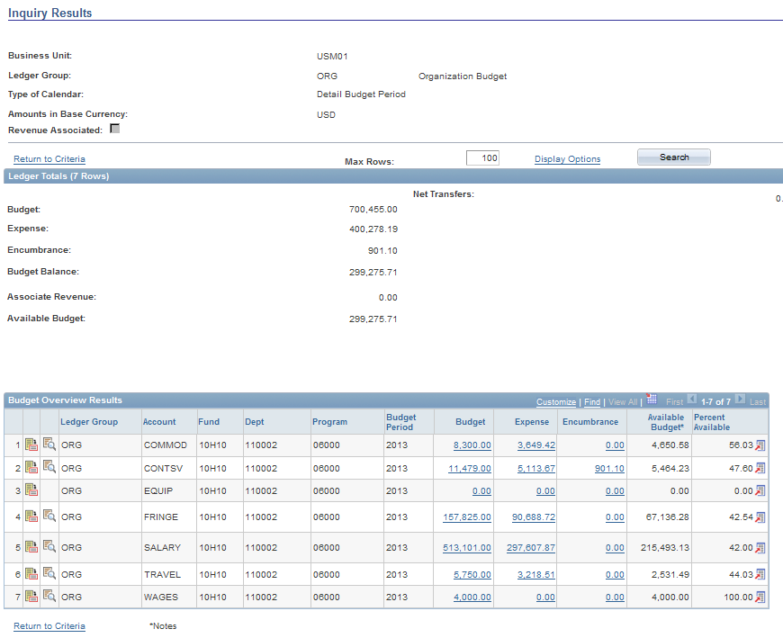Summary of Ledger Groups by Fund, Required Chartfields for Budget Overview

|  |  |  |  |
| --- | --- | --- | --- |
| **Fund Code** | **Ledger Group- Overall Budget (How much $ is available)** | **Ledger Group- Details for Revenue** | **Chartfield From Value** |
| 10XXX | ORG | REVEST |  |
| 12XXX | Fund , Dept ID and |
| 13XXX | Program |
|  |  |
| 14X10 | APPROP | REVEST | Fund & Dept ID |
| 14X20  14X25 |  |
| 50XXX | APPROP | REVEST |  |
| Program |
| 14X30 | PROJ_GRT | PROJ_REV | Project ID |
| 14X40 |
| 16XXX | PROJ_GRT | N/A | Project ID |
|

**Budgeted Funds:**

1. For E&G funds (10XXX), the ORG Ledger “BUDGET” amount is the allocation for the current budget period.
2. For Auxiliary funds (12XXX or 13XXX), the ORG Ledger “BUDGET” is the estimated cost of operations for the current budget period. The REVEST Ledger “BUDGET” is the estimated revenue expected to be generated for the fiscal year.
3. For Designated funds (14XXX), the APPROP Ledger or PROJ_GRT Ledger “BUDGET” is the ending balance of the prior fiscal year. (14% funds, year-end balance rolls over to the following FY as Budget). The REVEST or PROJ_REV Ledger “BUDGET” is reflected as zero. As monies are deposited, revenues are tracked as “Recognized Revenues”. Recognized revenues are linked to APPROP or PROJ_GRT Ledger budgets. In Budget Overview, the revenues are reflected as “Associated Revenue” and increase the Available Budget.

**Budget Balance Available:**

1. Budget – Expenses – Encumbrances (outstanding PO’s) = Budget Balance + Associated Revenue (if applicable) = Available Budget
2. For E&G funds, to calculate how much discretionary money you have to spend:

Available Budget $25,000

Less: Salary AB $15,000

Fringe AB $ 5,000

I CAN SPEND: $ 5,000

1. For Designated Funds the Available Budget is the balance left in the account.

**4- Transaction Drill Down:**

1. Pull up the budget in Budgets Overview. In the Budget Overview Results you will see the choices that are available for more details in BLUE. Click the BLUE # to get a listing of the transactions that are included in that total.

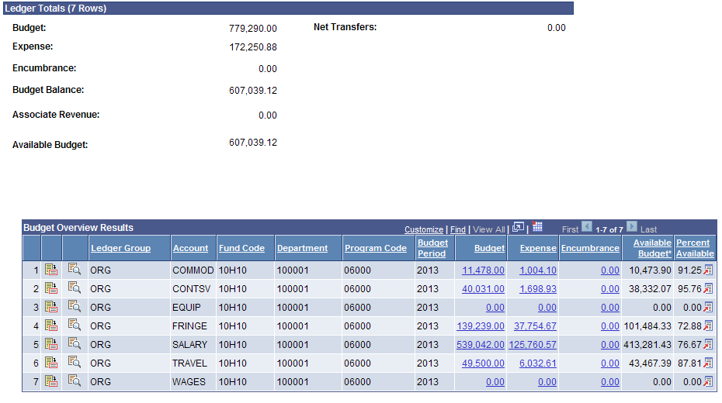

1. Once you get to the “Activity Log” panel – slick on the  to show all columns:

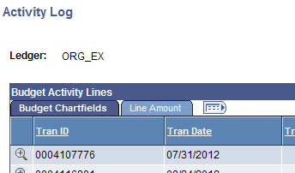

1. You are now able to sort the data. Sorting suggestions/tips:
   1. Tran Date = Date it was posted in the system (not the accounting date).
   2. Period = Period it is posted and will show up on your MDR (1 = July, 2 = August, etc.)
   3. Foreign Amount = amount each line item posted for.

You are able to sort the data by click on the header (i.e. Period, Foreign Amount).

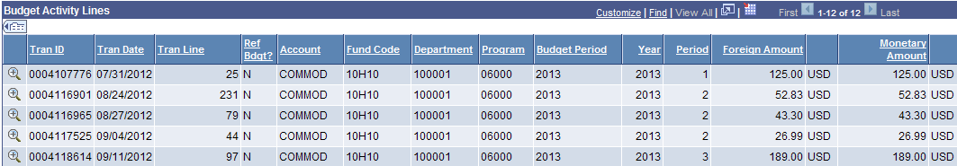

1. Identify the transaction you are interested in getting additional information regarding then click the  to get the additional information.

Examples:

1. **Journal Entries with Journal Prefix**:

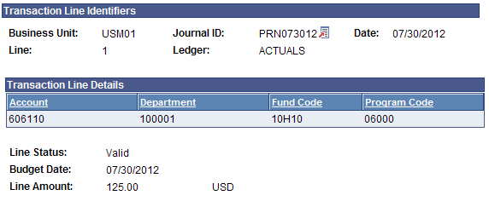

If the JOURNAL ID begins with letters – go to your Journal Prefix cheat sheet to identify the type of transaction. This example is printing charges for 7/30/2012 to 606110.10H10.100001.06000 for $125.00. This will show up on my JULY MDR.

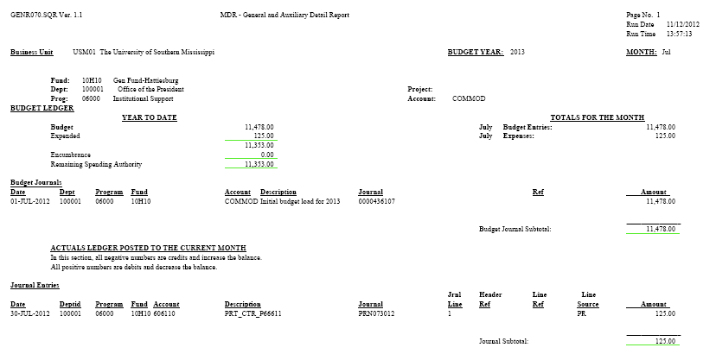

1. **Voucher ID**

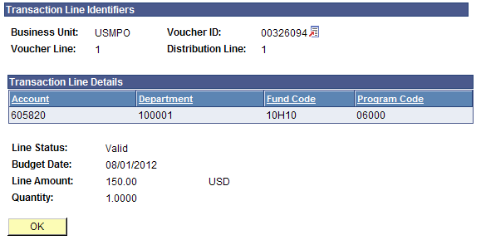

Click the  next to the Voucher ID#. Choose “GO TO SOURCE INQUIRY.” The below screen will show up

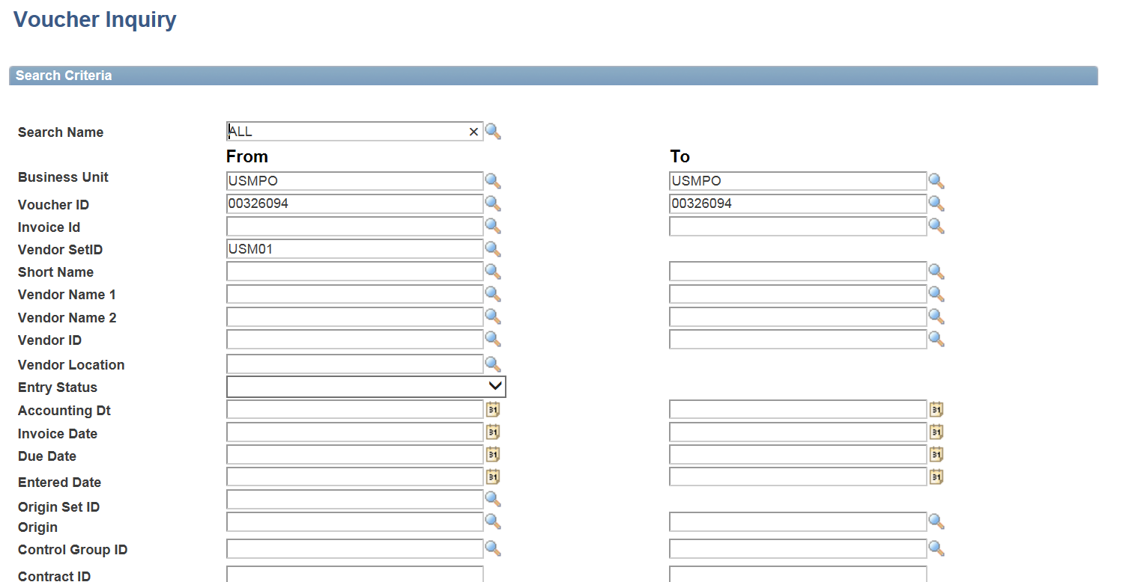

Scroll down

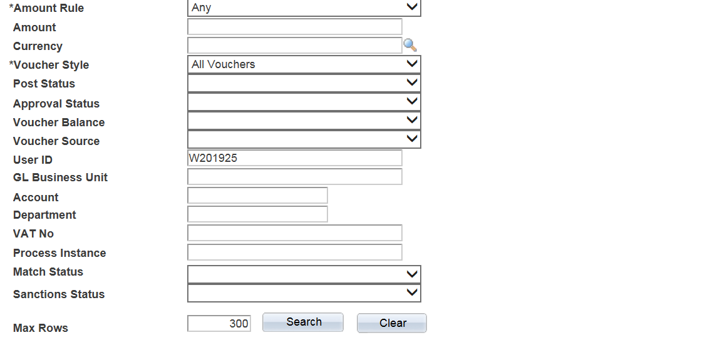

And remove your user ID, then click on Search

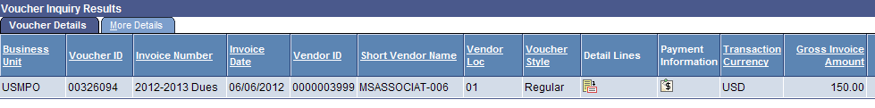

Under “Detail Lines” click the icon.

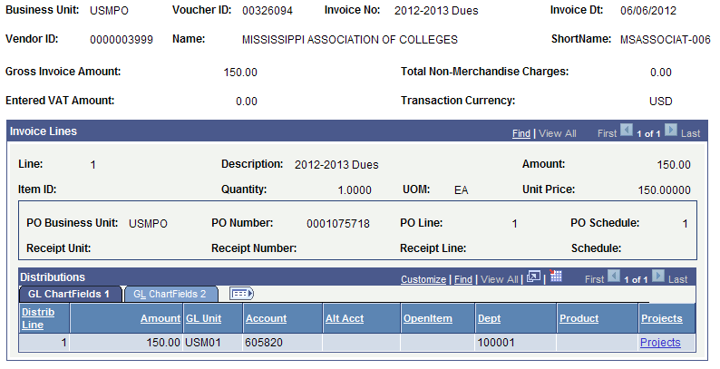

This screen will give you all the vital information related to the invoice (including the PO#, Vendor Name, etc.).

1. **Journal Entry beginning with 0000%**

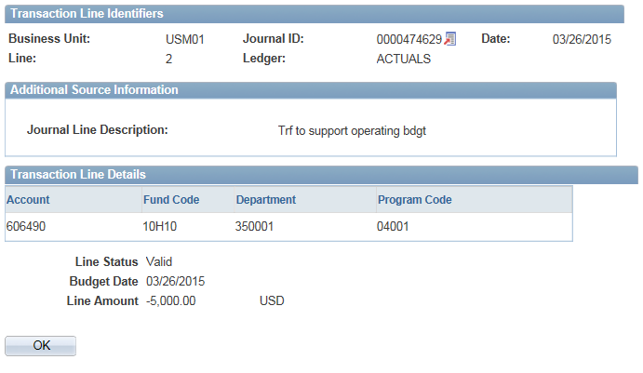

Click the  next to the Journal ID. Choose “GO TO SOURCE INQUIRY”.

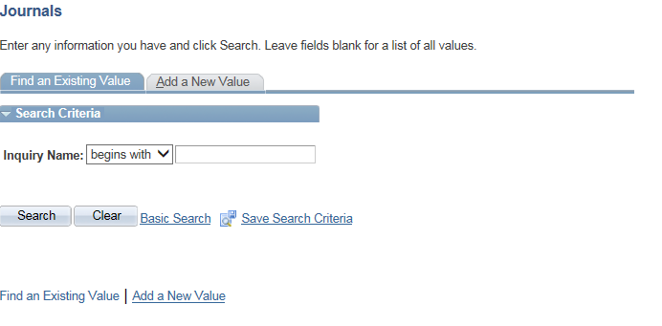

Then, click on Add a New Value

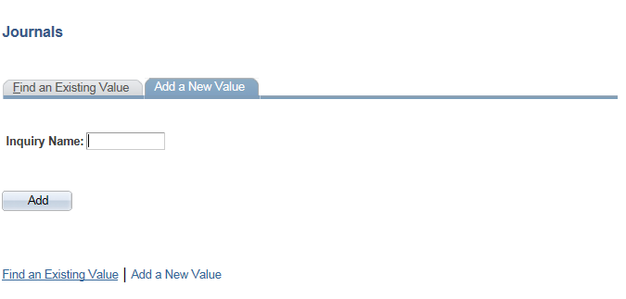

Set up an inquiry name with a name of your choice. For example “ACCOUNTS” and then click on  . The next screen will populate

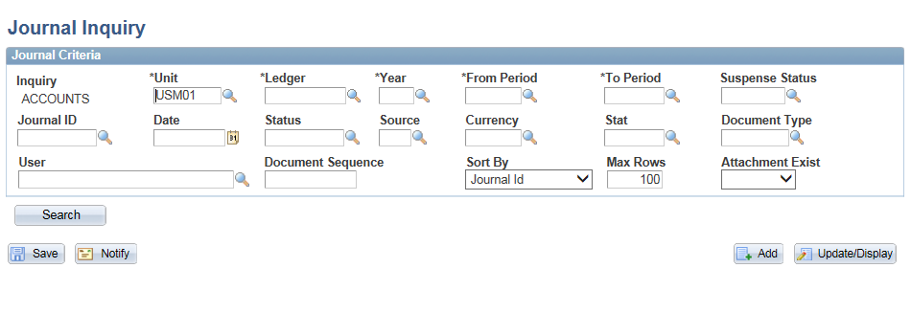

Fill out the Ledger (ACTUALS), Year (FY), From Period, To Period (Accounting Period, 1=July, 12=June) and click Save. This step will have to be done the first time that you go to source inquiry.

Hint: After you have created a run control, you will click on find existing value and click on the inquiry name (ACCOUNTS) that you have already set up.

Enter the Journal ID 0000474629 and click Search

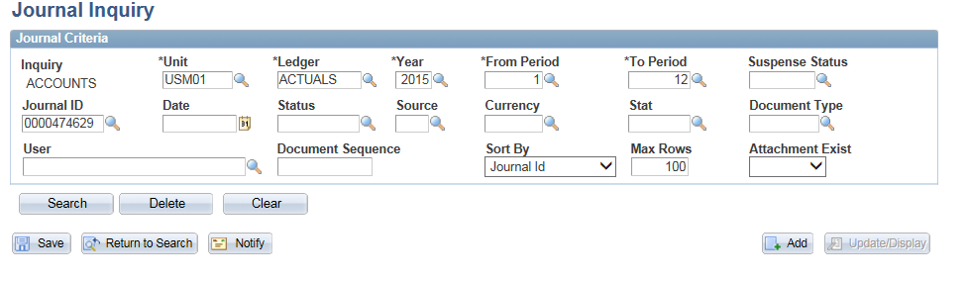

The Journal information will appear below

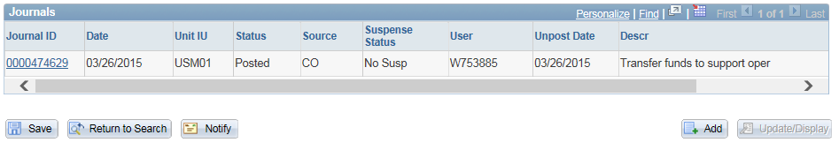

Click on the Journal ID # in blue

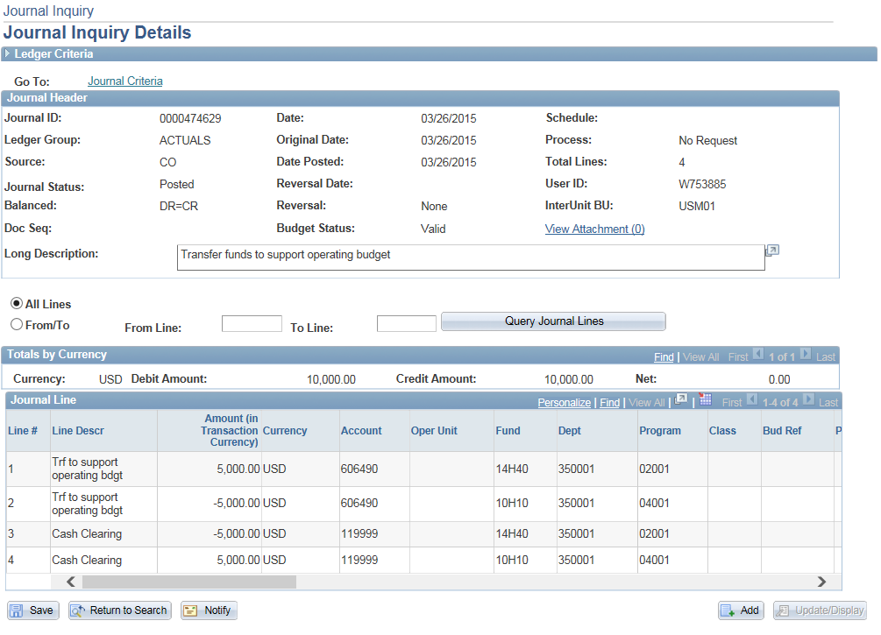

The screen above shows the Journal ID details.

**Departmental Deposit Report:**

This report will give you the details of the departmental deposits that are summarized on your MDR. The report also includes the receipt #.

NAVIGATION: USM Procedures – Departmental Deposit Report

Set up a Run Control ID. Fill out the panel based on your budget string.

Under “Select Departmental Deposit Report” choose either **CHARTFIELD** for budget strings that DO NOT have a project # or assigned or **PROJECT** for budget string that DO have a project # assigned.

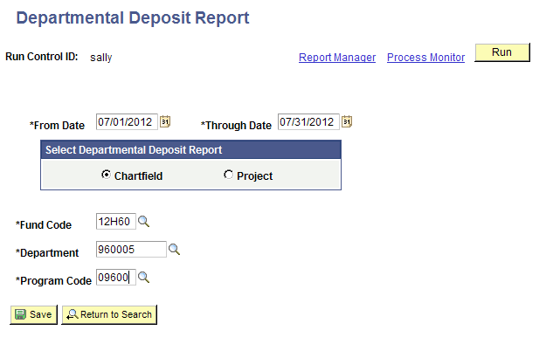

Click RUN.

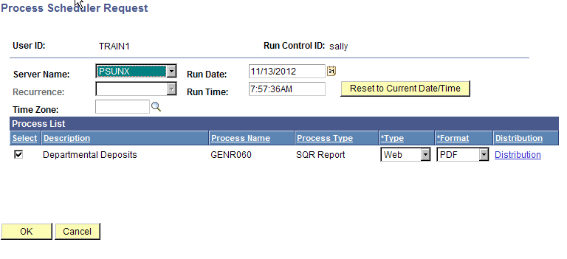

Server Name = PSUNX

Click OK.

(This will bring you back to the previous panel.)

Click Process Monitor.

Once your process says “Success” and “Posted”.

Click Details

Click View Log/Trace

Open the PDF.

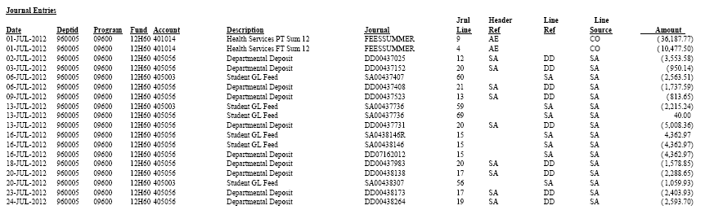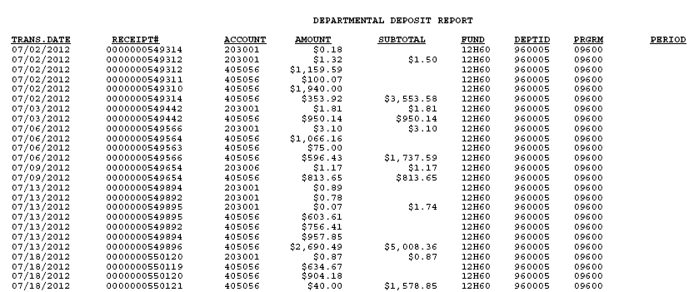

**Tips/Tricks:**

1. SoarFin Process Monitor is located at Main Menu – People Tools – Process Scheduler – Process Monitor.
2. P.O. Rollover at year end simply means you do not have to reenter the PO – it does NOT mean the money is rolled over – you have to pay for it with current FY money (not prior year).
3. The Year End Memo is on the Controller’s Office website around the beginning of May. This memo contains deadlines for yearend submissions of travel, accounts payable, interdepartmental invoices, procurement cards, physical plant work orders, technology purchases, etc.

**5 - Monthly Detail Report (MDR):**

MDRs are monthly budget reports that are run in SOARFIN. Number One Rule: Please do not attempt to run the report before you receive the email notification from the AVP for Finance stating these reports are now available. (This email comes via USMMAIL and USMTALK.) If the report is run prematurely, the information on the report will be inaccurate.

Report Choices:

|  |  |  |
| --- | --- | --- |
| Fund Code | Report Choices | Chartfield Information |
| 10XXX | MDR_General&Auxiliary_Detail |  |
| 12XXX | Fund, Dept ID and |
| 13XXX | MDR_General/Auxiliary_Summary | Program |
|  |  |
| 14X10 | MDR_Designated and Agency Funds | Fund, Dept ID and |
| 14X20  14X25 | Program |
| 50XXX | MDR_Designated and Agency Funds | Fund, Dept ID and |
| Program |
| 14X30 | MDR_Projects and Grants_Detail | Project ID |
| 14X40 |
| 16XXX | MDR_Projects and Grants_Detail | Project ID |
| MDR_GRXXXXX Grants_Summary |

Example of how to run report for 14H10.350014.01001:

Navigation: USM Procedures -- (Choose correct report) in this case, MDR Designated and Agency

(If first time, “Add a New Value” and create a run control)

(Any other time, click SEARCH)

Helpful Hint: Set up each report on a different Run Control ID. This will allow you to run several reports at the same time.

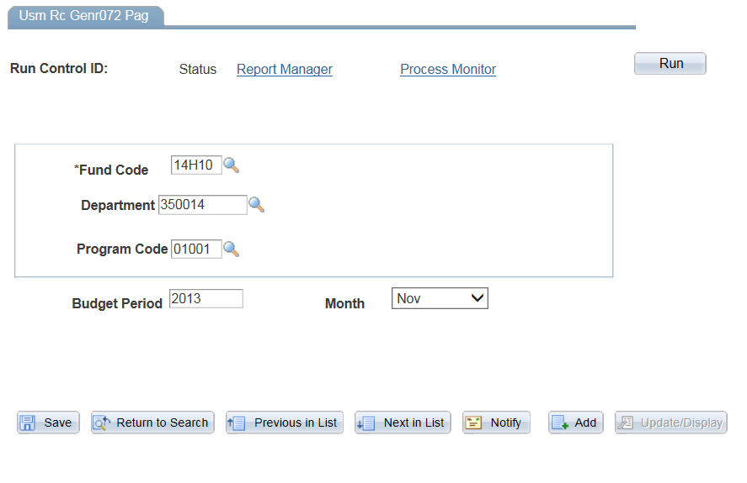

Enter all of the necessary information (see cheat sheet above). Budget Period = Fiscal Year (not calendar year). Click Run

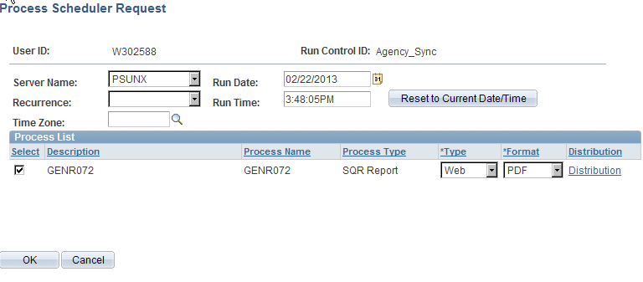

Make sure your SERVER NAME is PSUNX and click OK. (It will then take you back to the first screen automatically.)

Next Click Process Monitor (next to the RUN button) when you are on the first screen.

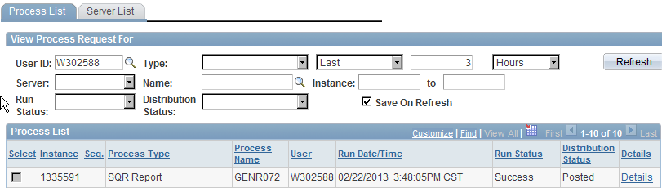

Then click Refresh every couple of minutes until it says “Success” and “Posted”. Click Details.

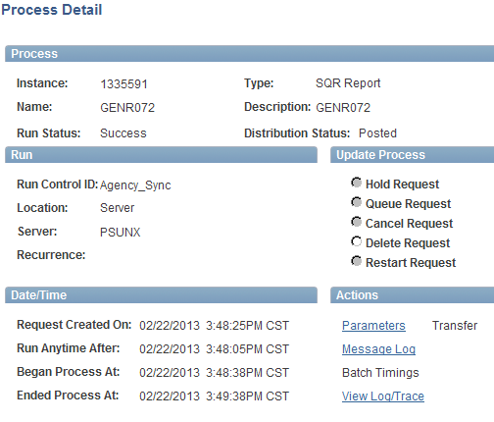

Click “View Log/Trace” – at the bottom.

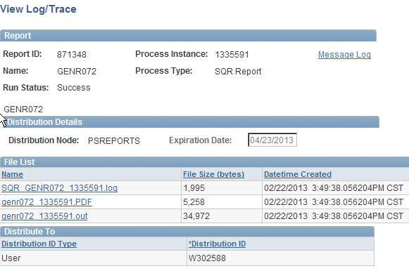

Click the PDF File (it’s the middle blue link). At this point you can save and/or print just like any other PDF file.

* If you do not pull your report at this point and want to go back to Process monitor later or the next day the report will still be available. You will need to adjust the number of days of reports listed.

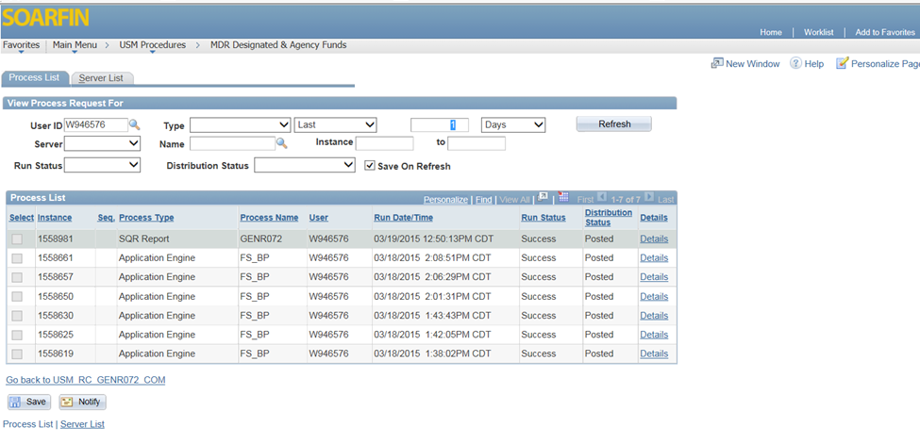

Reconciling Budgets:

Reconciliations of all University budgets are required to maintain the integrity of the University’s accounting records and to protect the interests of the University. Reconciliations are essential for an effective internal control environment so that:

* The information transmitted to, contained in, and reported from the University's financial systems is accurate, complete and recorded in a timely manner;
* The information can be relied upon for making financial and administrative decisions; and
* Irregularities are quickly detected and reported to the appropriate authorities.

TIPS:

1. Attach copies of receipts/paperwork related to transactions with your MDR and file for a minimum of three years (the University is currently working on an official retention policy – three years is the current standard from the IRS).
2. If you aren’t sure about a transaction, look at the Source Code and contact that particular office for additional information.
3. If you are working on a grant, remember that auditors are constantly coming in to audit those grants and they always check financial records.

RECONCILE! RECONCILE! RECONCILE!!!!!!

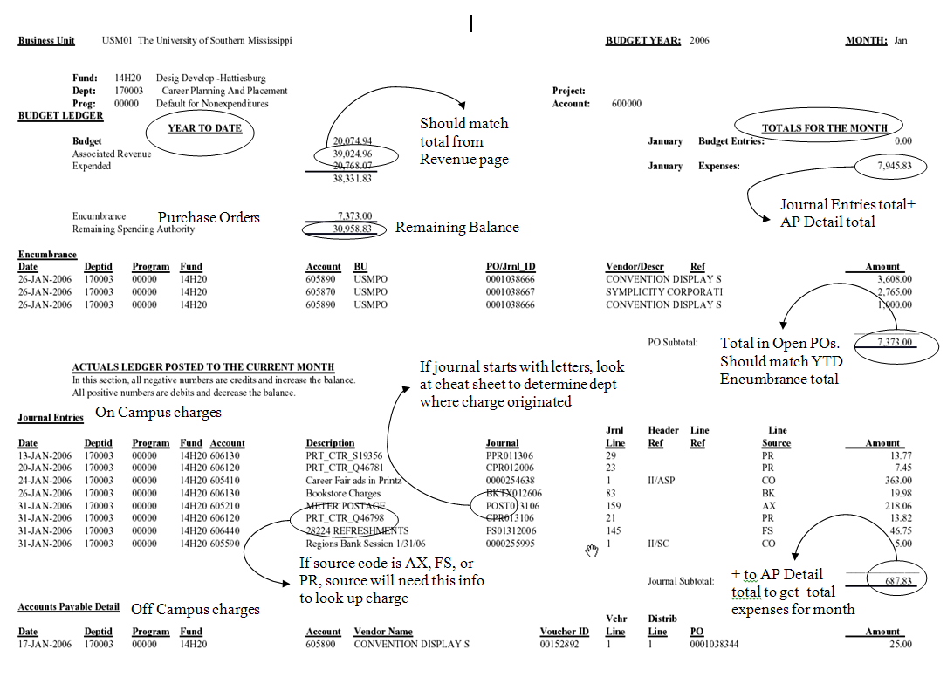

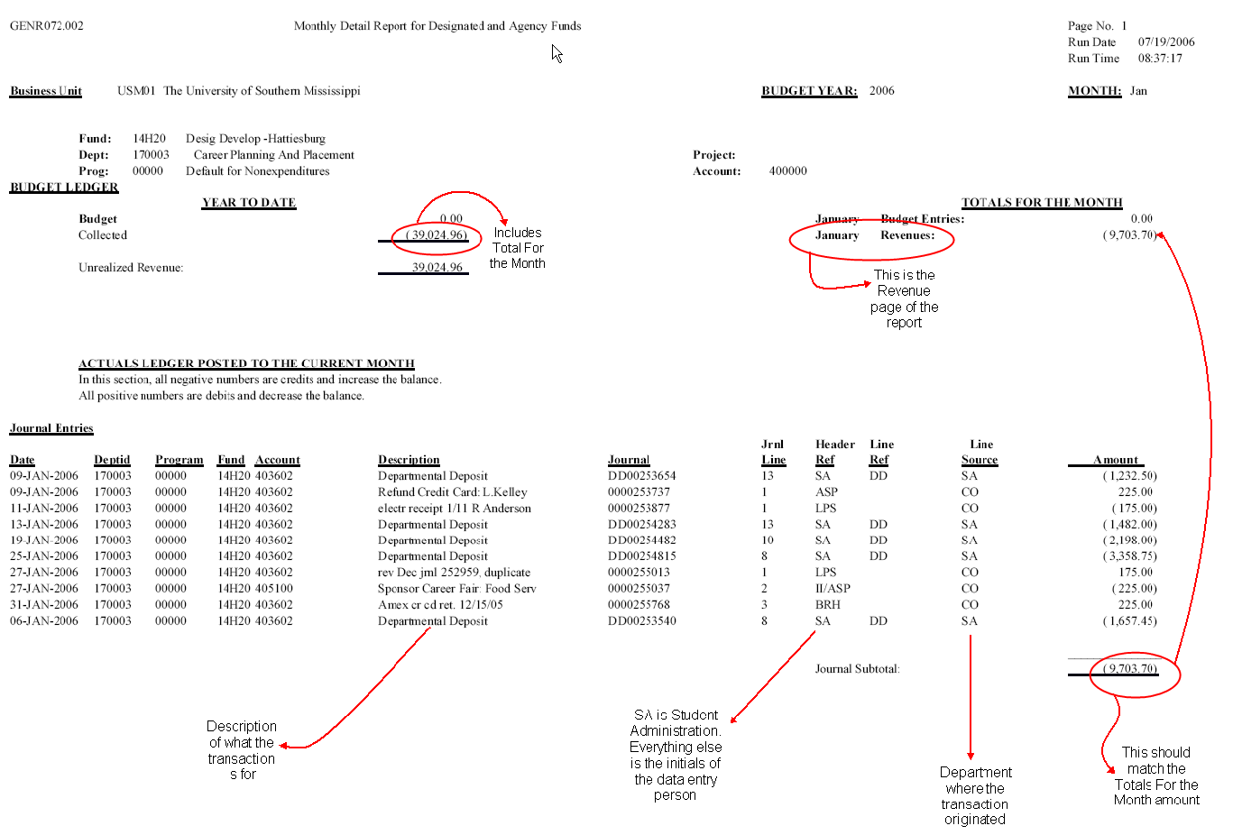

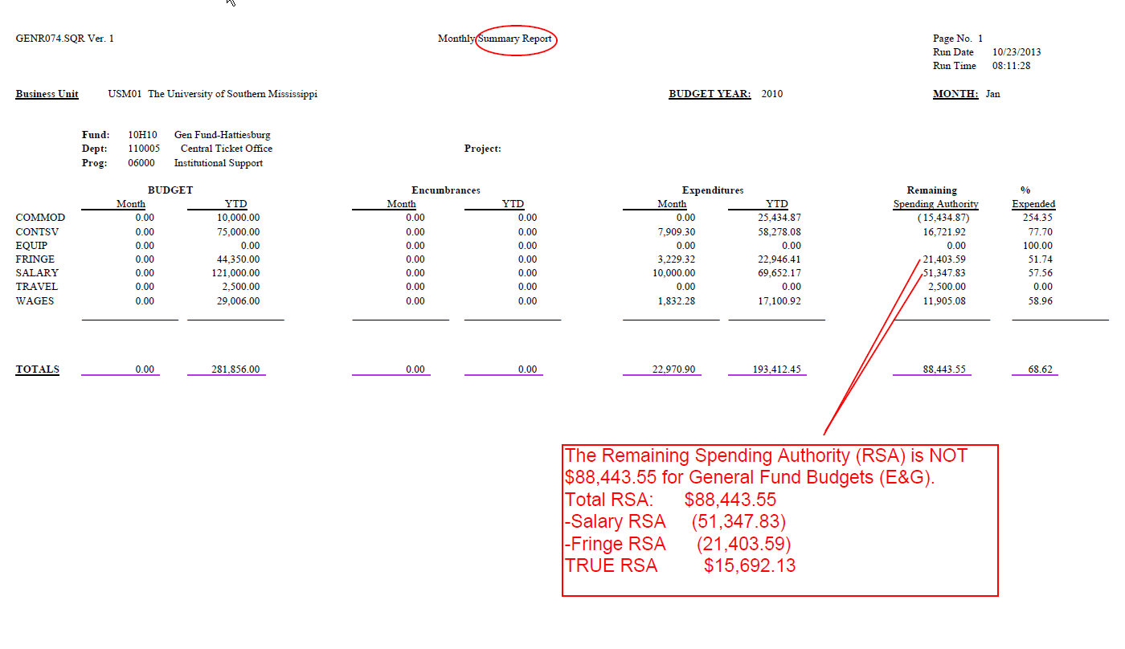

|  |  |  |
| --- | --- | --- |
| **Jrnl Prefix** | **Contents of File** | **Contact** |
| **ANSV** | Annual Box Rent from Post Office | Tim Laird |
| **BKTV** | Bookstore Charges | 6-4388 |
| **DD** | Departmental Deposit | Riley McWhorter |
| **FS** | Food Service Charges | Marlene Beato |
| **HDWARE** | Hardware/ Computer Purchases from Itech (Prior FY 12) | Paige Strickland |
| **TECHPR** | Hardware/ Computer Purchases from Itech | Paige Strickland |
| **HR** | Payroll | Payroll Department 6.4084 |
| **PC** | Procurement Card | Saundra Garnand |
| **PHOT** | Photo Services Charges | 6.4149 |
| **POST** | Post Office Metered Postage Charges | Tim Laird |
| **COPY** | Quick Copy sales & Paper Sales | Chante Ravesies |
| **PRN** | Printing Sales: Print Center (Prior to 12.01.14) | Cassie Oubre |
| **RCC** | RC Cook Union Rentals | April Broome |
| **SA** | Student Feeds | Barbara Madison |
| **SC** | Fisher Scientific | Jacob Cochran |
| **SHIP** | Shipping Charges | Tim Laird |
| **TCC** | Thad Cochran Center Rentals | April Broome |
| **ITBL** | Itech Billing: Phone Charges, Services, etc | Paige Strickland |
| **UC** | University Communications Printing | Cassie Oubre |
| **UPS** | UPS Charges | Tim Laird |
| **VID** | University Communications Video Production/ Services | Cassie Oubre |

**Who to Call for Information**

**Title Name Phone #**

Accounts Payable/Travel Sheila Sims 65668

Accounts Receivable Barbara Madison 65791

Affirmative Action Tonya Guillory 65117

Alumni Association Jerry DeFatta 65013

Athletic Tickets Chris Condit 65418

Auditor Vijay Patel 64231

Auditorium Manager Robert Ross 65620

Benefits – Manager Amy Hester 64055

Bookstore/Retail Sales – Director Kathy Hayman 64384

Bookstore – Supply Buyer/Arts Linda Baldwin 66482

Budget/General Funds (10%) Lynn Smith 64091

Budget/Auxiliary Funds Lynn Smith 64091

Budget/Designated Funds (14%) Agustina Pesci 66755

Business Services – General Info Barbara Madison 65791

Chartfield Maintenance Melissa Bastine 66677

Communication Resources Paige Strickland 64010

Contracts & Grants Actg Gale Pigott 65086

Controller’s Office – General Info Rebecca Golden 64084

Controller’s Office – Fin. Stmt/Actg Melissa Bastine 66677

Copy Center Chante Ravesies 65455

Cost Accounting Policies & Procedures CorrieThompson 64100

Departmental Deposits – Univ. Cashier Dorothy Thompson 64146

Eagle Club Information Chad Foote 65299

Electrical/Mechanical Anthony Sumrall 64421

Employee Assistance Program Wanda Naylor 64053

Employment Information Wanda Naylor 64053

Enviro. Svcs – Moving/Tables/Chairs Rodger Jackson 64850

Facilities & Administration Costs Corrie Thompson 64100

Food Services Marlene Beatty 66498

General Accounting Melissa Bastine 66677

Human Resources –

Benefits Manager Kameron Dale 64056

Human Resources –

Classification/Compensation 64050

Interdepartmental Invoices – Acctg Melissa Bastine 66677

International Stds/Employees Suzanne Omran 64841

**Title Name Phone #**

Library Lisa Jones 64244

Monthly Detail Reports – Accounting Agustina Pesci 66755

Payroll – Director Peggy McArthur 66625

Photo Services 64149

Physical Plant Chris Crenshaw 64420

Post Office Tim Laird 64006

Procurement Steve Ballew 64131

Proj. Estimates & Construction Mgt Rita Hailey-Burkes 64426

Property/Tagging/Inventory Donnie Robbins 64439

Purchasing – Pcard/State Contracts Deidre Edwards / Heather Kihyet 64132/33

Purchasing – Workflow Jessica Turner 65174

Purchasing – Computers, Scientific Eq. Jessica Turner / Heather Kihyet 65174/4133

Recycling Heather McMinn 65687

Registrar Greg Pierce 65006

Remittance Voucher Information Angela Thomson 66310

Research Administration (Office of) Heather Richey 64119

Salary Recovery & Distribution Corrie Thompson 64100

Student IDs 64149

Tax Compliance Cheri Waldrup / Melody Duncan 64102

Technology Resources – Director David Sliman 65479

Textbook/Course Material Buyer Kay Bush 65107

Tradebook/General Book Buyer Maggie Amerson 64386

Time and Effort Certification Christy Harvey 66312

Transportation/Parking Lucy Bowens 64986

Travel Information Rayonne Grant 64038

Work Orders – Physical Plant Tonia Shaw 64414

**Finance Administration Phone Numbers**

Accounts Payable 6.5668 ORA 6.4119

Business Services 6.4771 Physical Plant Accounting 6.4414

Controller’s Office 6.4084 Procurement Services 6.4131

Grants A/R and Billing 6.5084 Travel 6.4131

GRCL Business Office 2.4205

Human Resources 6.4050

OFPA – HB 6.4091

OFPA – GP 5.4571



**5- Payroll Distribution Report (PDR)**:

This report is available in SOARHR (not SOARFIN). The report displays the details of the Salary, Wage and Fringe amounts that are charged on your Monthly Detail Report (MDR) for the journals with a source code equal to HR.

Navigation Path in SOARHR:

Payroll for North America – USM Payroll – USM Manage Payroll – Report N-Z – Payroll Distribution Report

(If first time, “Add a New Value” and create a run control)

(Any other time, click SEARCH)

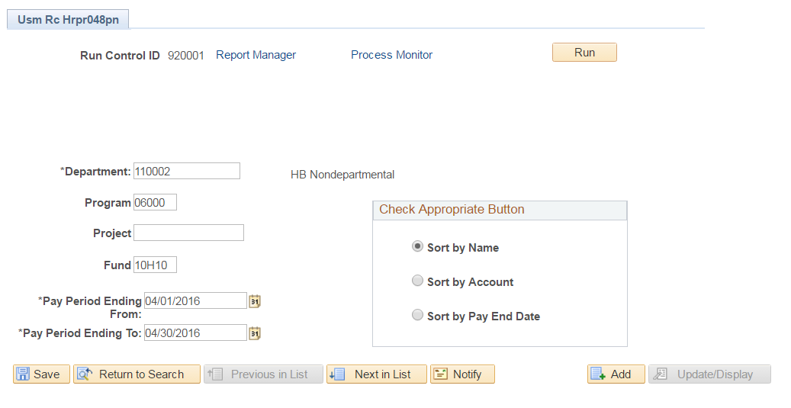

Type in the budget string (department, fund, program, and/or project), Pay Period Ending From, Pay Period Ending To, and select a sorting option.

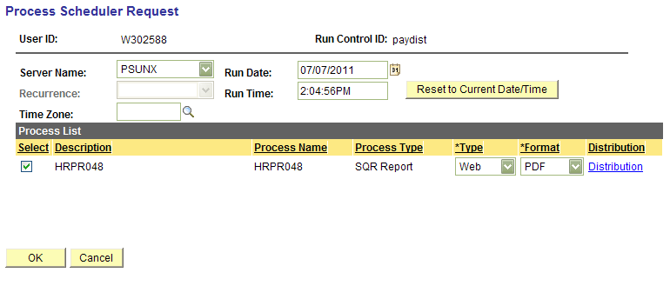

Make sure your SERVER NAME is PSUNX and click OK. (It will then take you back to the first screen automatically.) Click Process Monitor (next to the RUN button) when you are on the first screen. 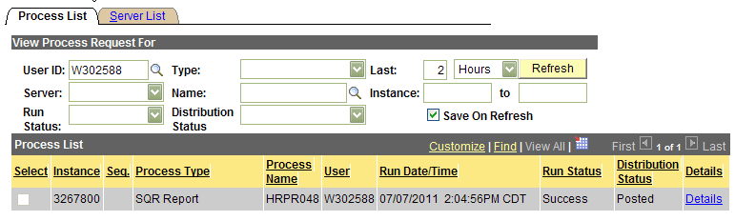Then click Refresh every couple of minutes until it says “Success” and “Posted”. Click Details.

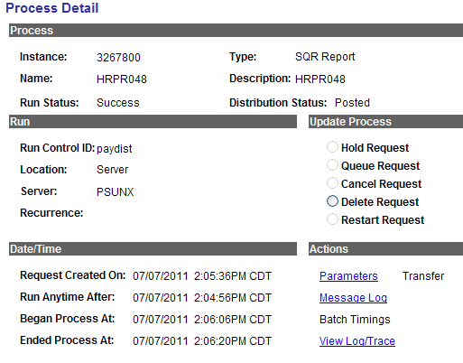

Click “View Log/Trace” – at the bottom.

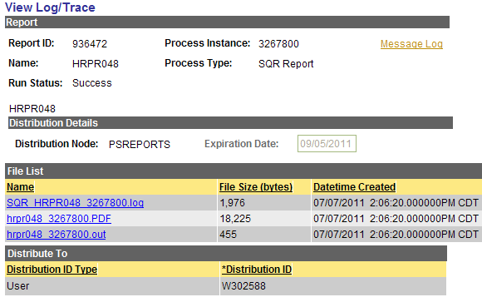

Click the PDF File (it’s the middle blue link). At this point you can save and/or print just like any other PDF file.

