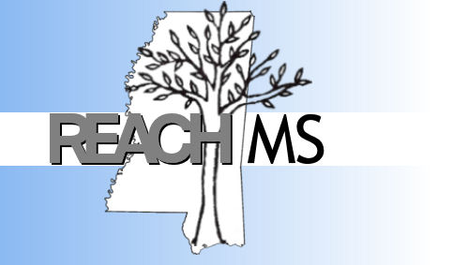
REACH MS
Mississippi’s State Personnel Development Grant
University of Southern Mississippi Phone: 601.266.4693
118 College Drive #5057 Fax: 601-266-4691
Hattiesburg, MS 39406 Email: REACHMS@usm.edu

Realizing Excellence for ALL Children in Mississippi

MTSS PBIS Tier 1
TFI Feature | In Place | Not In Place | Implemented | Evidence
1.1 Team Composition
- Tier 1 Team Roles and Responsibilities form

1.2 Team Operating Procedures
- Tier 1 team meeting schedule – date, time and room

1.3 Behavioral Expectations
- 3-5 positively stated behavioral expectations
- 5-6 rules for each setting as examples of the expectation
- Posted in all areas

1.4 Teaching Expectations
- Written lesson plans for teaching the expectations and rules for each area of the school
- Implementation plan for:
- Kicking Off PBIS with students
- Teaching the expectations and rules to students in each area

TFI Feature | In Place | Not In Place | Implemented | Evidence
1.7 Professional Development
- Written process for teaching staff about expectations & rules, reinforcement system, how to correct inappropriate behaviors, requesting behavioral assistance
- Implementation plan for teaching staff the
- Expectations and rules to staff for each area
- Reinforcement System
- How to correct inappropriate behaviors
- Requesting assistance
1.8 Classroom Procedures
- Tier 1 PBIS systems are being implemented in classrooms (including expectations/rules, reinforcement system, and continuum of consequences
1.9 Feedback and Acknowledgement
- A formal system of reinforcement with written procedures for specific behavioral feedback that is:
- Linked to school-wide expectations
- Used across all settings and within classrooms
- Implementation plan for reinforcement system
- Token system
- Reinforcement menu
- Schedule of reinforcement
for the rest of year

TFI Feature | In Place | Not In Place | Implemented | Evidence
1.10 Faculty Involvement
- School-wide data is shared with staff regularly (monthly)
- Faculty provide input yearly on Tier 1 systems:
- Expectations/rules
- Reinforcement
- Behavioral definitions
- Consequences
1.11 Student/Family/ Community Involvement
- Stakeholders provide input yearly on Tier 1 systems
- Expectations/rules
- Reinforcement
- Behavioral definitions
- Consequences
  - Discipline Data
- PBIS Team has instantaneous access to
  - School-wide Big 5 graphs
  - Individual BIG 5 graphs
  - Data-based
Decision Making
- PBIS Team reviews and uses BIG 5 graphs monthly for decision making including developing a Precise Problem Statement and possible solutions

