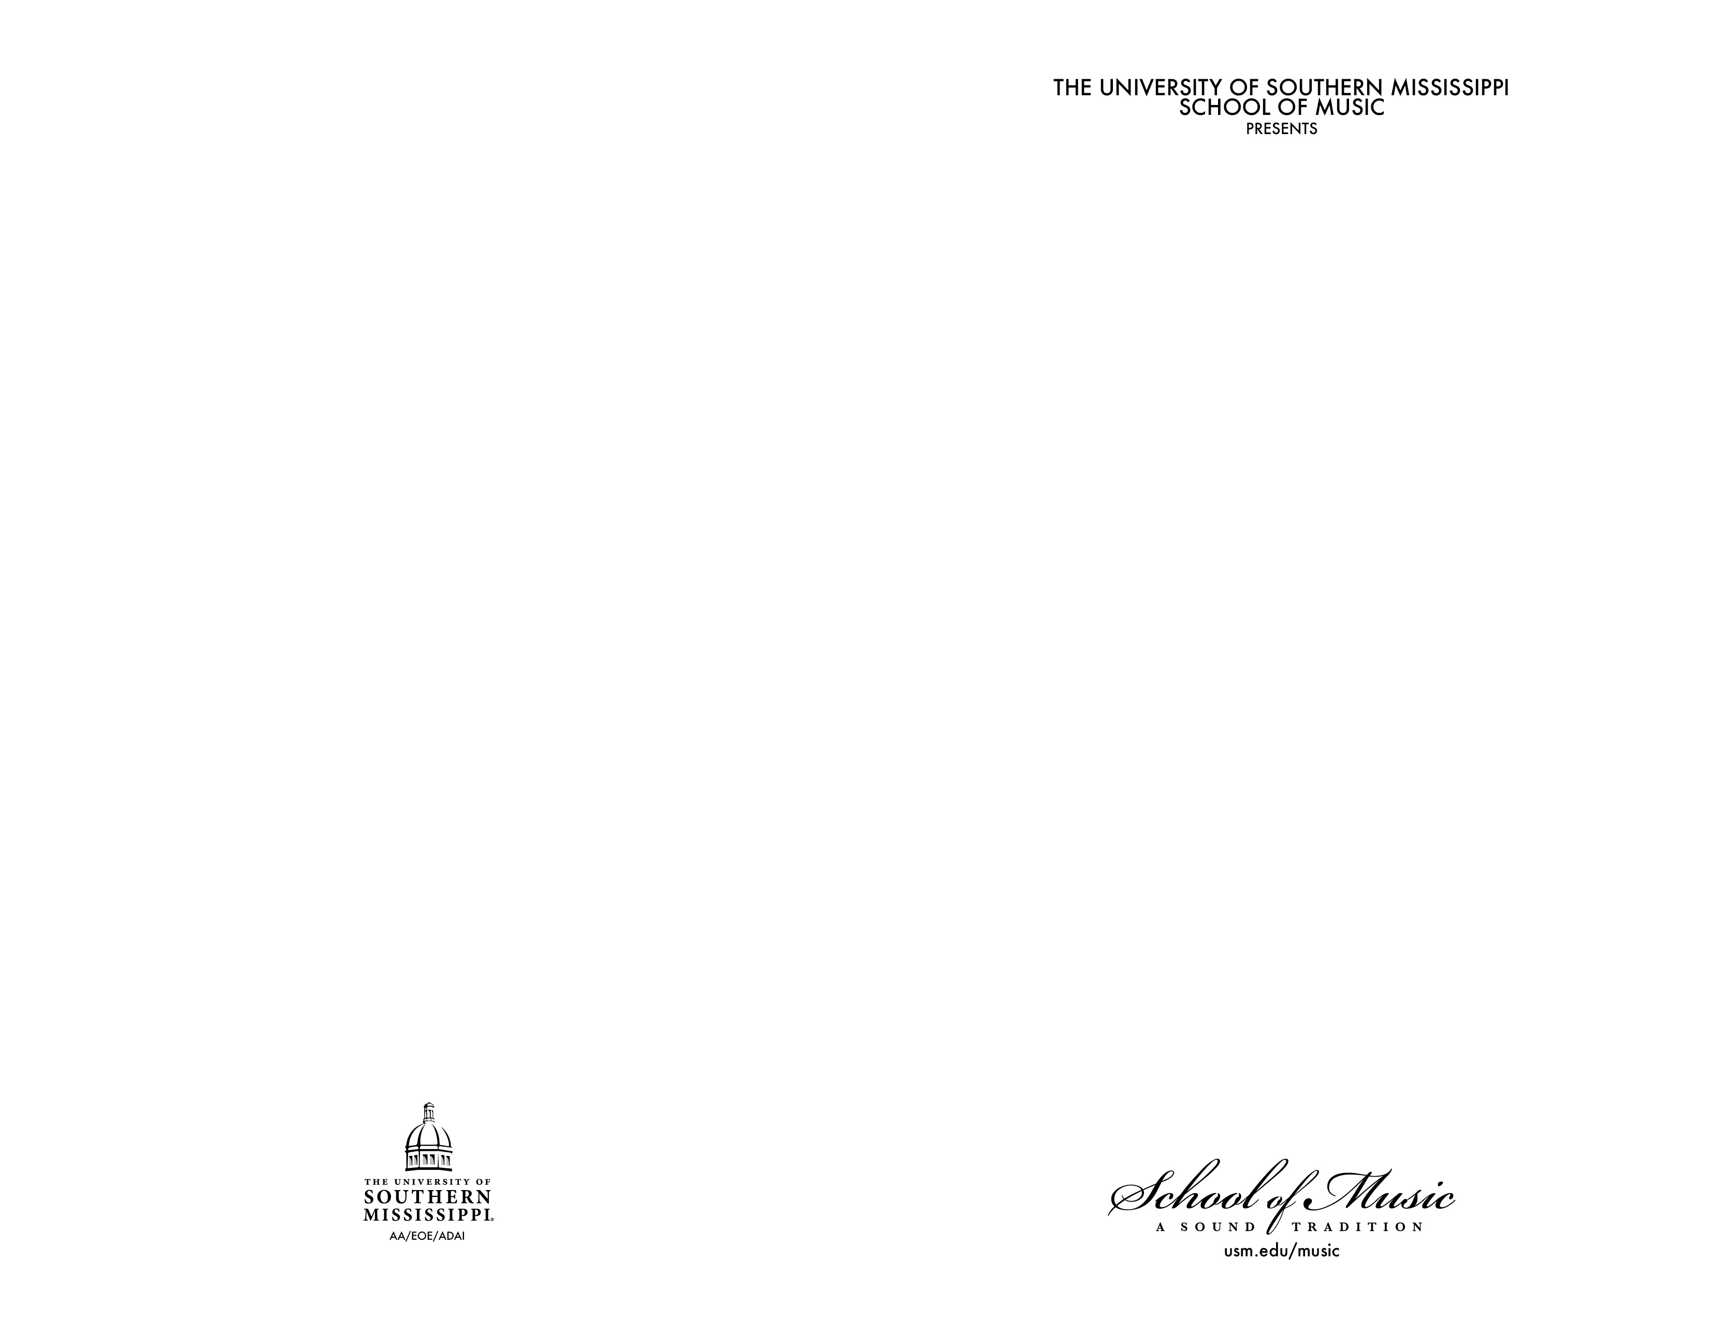

INSIDE RIGHT

INSIDE LEFT