
How Do I Schedule Exams in Accommodate?
Students taking in-person exams with accommodations can use the Accommodate system to schedule their exams. Students can only schedule exams for the times that their class meets. If you are in an online class or are making a request to take an exam outside of your normal class hours, please contact us by email (sas@usm.edu) or by phone (601.266.5024).
SAS proctors exams Monday through Friday. Exams may begin between 8:30 AM and 3:00 PM. Please remember that all exams must be scheduled 48 hours (2 days) in advance.

- Open your Accommodate portal: https://usm-accommodate.symplicity.com/students/

- In the toolbar on the left, click Testing Room. At the bottom of the screen, click on the New Booking Request button.
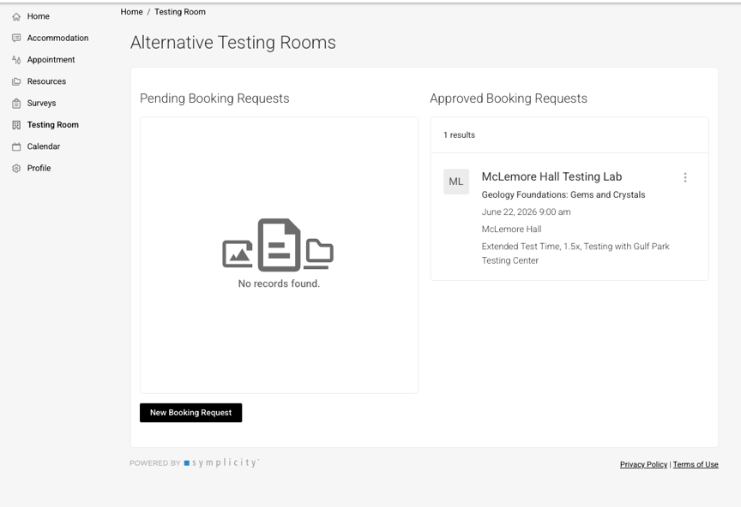

- Select Filter – Use the dropdown menu to select the course you are scheduling an exam for. Click Next Step.

- Select Date – Regular exams can only be scheduled during times when the class meets.

If you are an online student, or if your exam is scheduled outside of normal hours, you can schedule your exam with SAS through email (sas@usm.edu) or by phone (601.266.5024)

- Select Space – Your available testing times will appear in this box. Select your exam time by clicking Request.

- Confirm Exam Booking – Once you select an exam time, you will see the pop-up screen below:
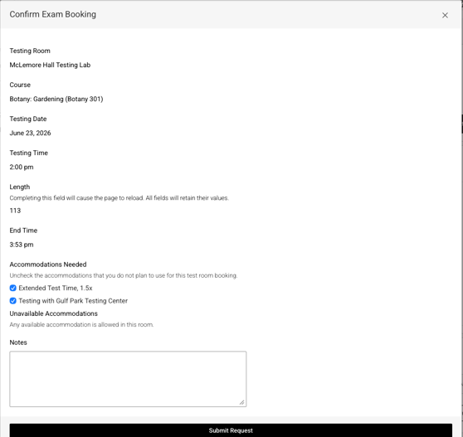

- Submitting Request – Double-check all of your information, select the accommodations you’d like to use, and add any notes that you think are necessary. When you are done, click Submit Request.

SAS staff and your instructor will receive a notification of your request. You will receive a confirmation email of the request and its approval. All requests can be approved or denied by your instructor, depending on when you request to take the exam.

