

First, thank you for participating in this stepping-stone for your student’s college scholarship process. Below are ways to troubleshoot issues you may have regarding the GO System.

LOGGING IN/GETTING TO YOUR APPLICATIONS:
- Here is the link for the GO System. You can also access this link from the USM Office of Undergraduate Scholarships’ home page (usm.edu/scholarships) and click the gold “GO SYSTEM” button.
- Click the “Sign in” button on the top right

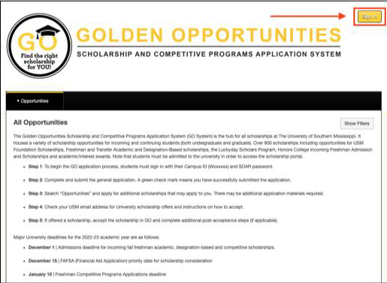

- On the next page, select the Reference and Reviewers tab.

- 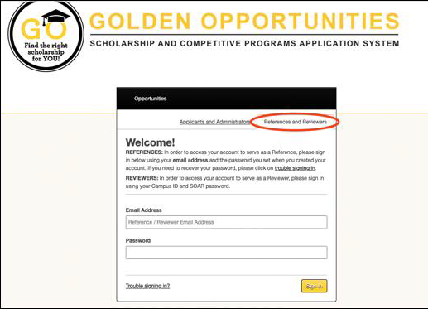

Things to note
  - No one but a current USM student or faculty/staff member can use the sign-in with your institution gold button
  - If you are a current employee or have current SOAR credentials, you will use those Iogins (wID@usm.edu + SOAR password).
  - If you are a past employee/have recently retired from USM but still have a USM email address, you will need to reset your password. To do this, select Trouble signing in? at the bottom of the login box and enter your USM email address.
  - If you are an alumni reviewer, you will log in using your email and the password you created. If you no longer have access using this information, you will need to reset your password. To do this, select Trouble signing in? at the bottom of the login box and enter the previous email address.
  - If you are current employee with GO Administrative access, you are able to login through the Applicants and Administrators tab as usual, but once you’ve signed in, you will need to hover over your name (on the right side of the black bar) and a select “Reviewer” under the Roles section in the dropdown.

Additional information

- For references not receiving their student’s link…

First, please check your spam or junk folder. If the reference is not in a spam or junk folder, please have the student verify that they’ve sent the reference to the correct e-mail address and that their entry of your e-mail address is spelled correctly. Once verified, the student can resend the request by either updating the entry on their application or following the path References ➔ Resend Request from their home page. This action should send a new e-mail containing a link to the reference form.

- If references are experiencing interference from school firewalls…

The student may need to utilize a different email address for the reference. References may also need to complete the process while off campus. If the reference is unable to login, this may be due to the student receiving the incorrect email or ending the address with .com, etc. The email will likely be firstname.lastname@usm.edu.

To prevent future issues, work with your school district technology department to add scholars@usm.edu to the safe senders list.

- If the student would like us to pull the reference…

We are able to pull the student’s original reference request link from our Golden Opportunities Application System (GO System) database if needed. We can then forward the reference request directly to the reference. If this action is needed, please send the individual student’s name, their student ID, and name of their reference. Please note that we are unable to pull student information or references by schools or groups.

For additional questions concerning the Luckyday application process, please contact the Luckyday Scholars Program at https://www.usm.edu/luckyday-scholars/index.php.

For additional questions concerning the Honors College application process, please contact the Honors College at 601-266-4533.

If you have any additional questions or concerns, please feel free to contact our office. We will be happy to help. The USM Scholarship Office can be reached at 601-266-4540 or scholars@usm.edu

