

How to Submit a Final Report for DCUR Grants
- On the Competition Review Nexus homepage, click the Log In link on the upper right hand side of the page.
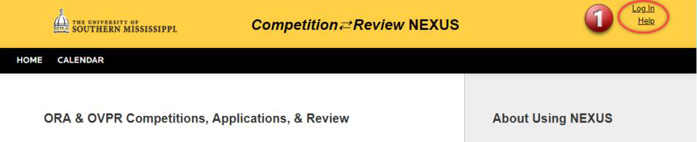

- On the next page, click the University of Southern Mississippi Login.
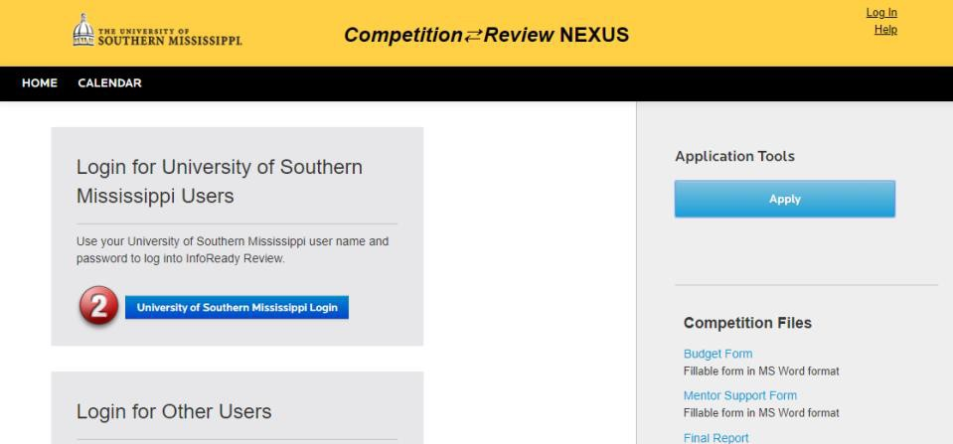

- On the login page, use your CampusID credentials to log in.
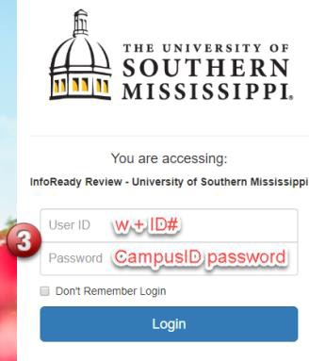

- On your Competition Review NEXUS home page, click Applications at the top of the page.


- The Applications page will list all of the applications you have submitted to competitions through Competition Review NEXUS. Click the paper icon on the right side of the row for the application/competition that corresponds to the final report you are submitting.
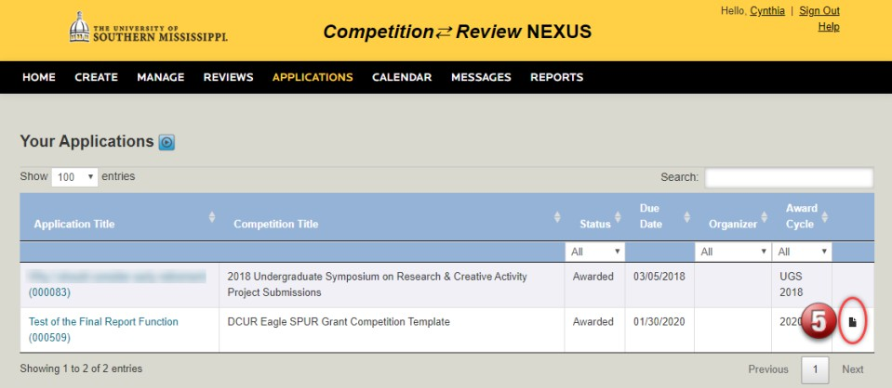

- If you have not already downloaded and completed the final report form, it is available on this page.
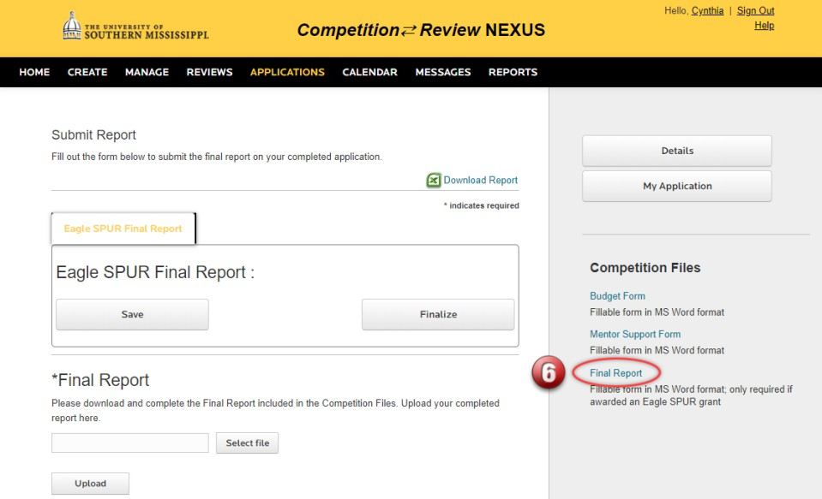

- If you have completed the final report form and are ready to submit, click the Select file button to choose the file to upload.
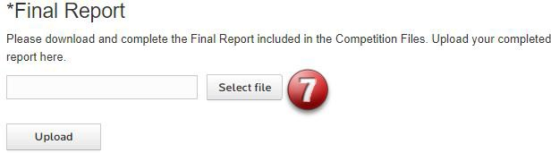

- After selecting your file, click the Upload button to upload your report.
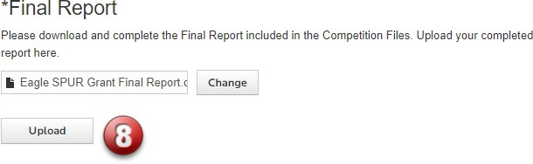

- After uploading your report, click the Finalize button to submit your report.
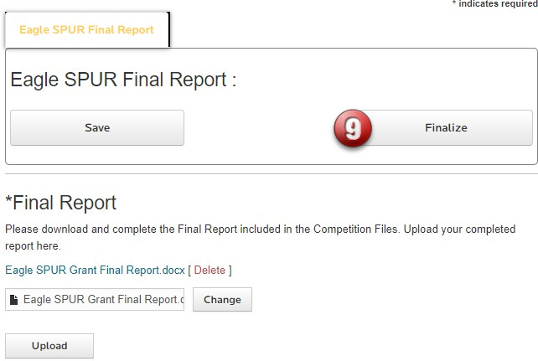

- If you have uploaded and finalized your report successfully, you should get the two messages displayed below.
